1. Install ngnix and run ngnix on port number 81.



1. Deploy a sample index.html file on ngnix.



1. Install Apache and run Apache on port number 82.

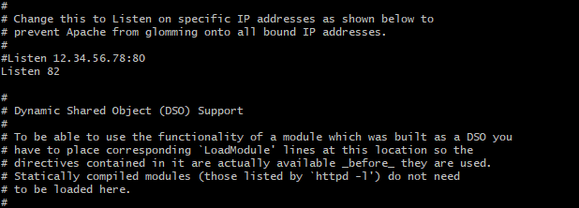

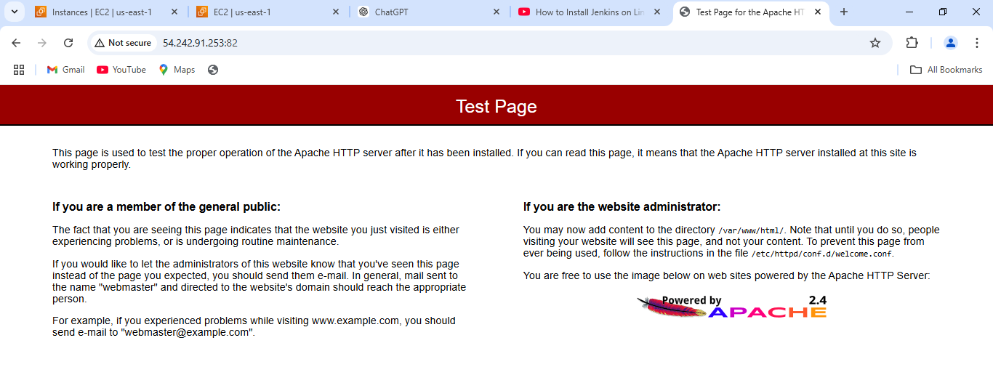

1. Deploy a sample index.html file on Apache.

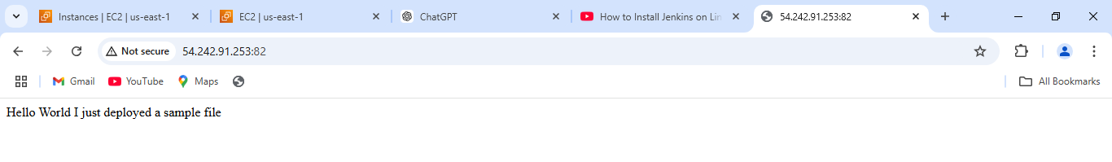

1. Install Apache tomcat on port number 8082.

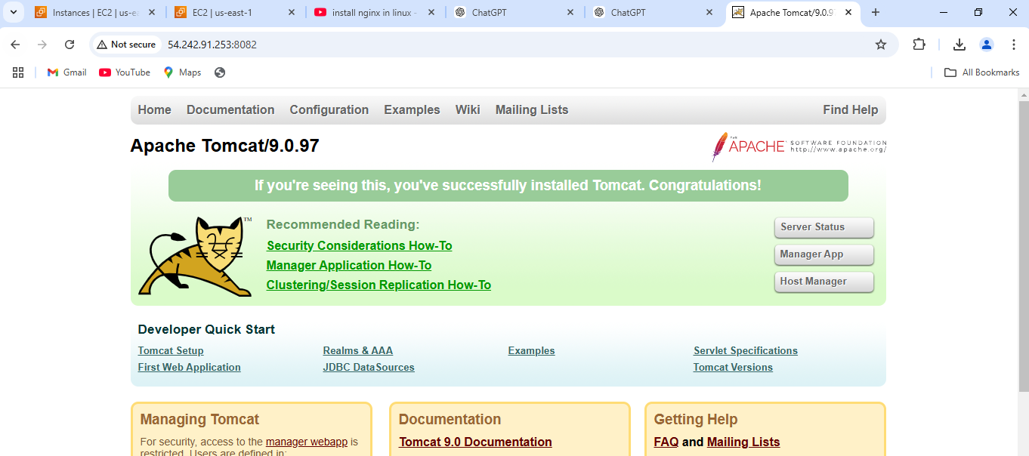

1. Deploy a sample app on webapps.

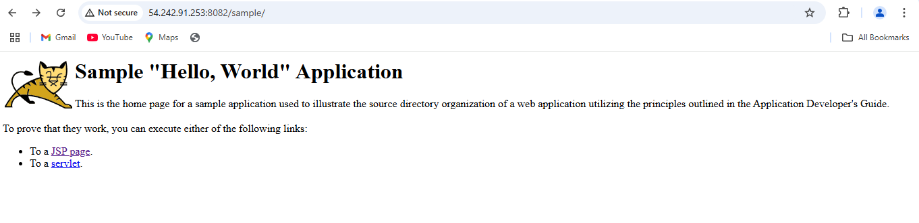

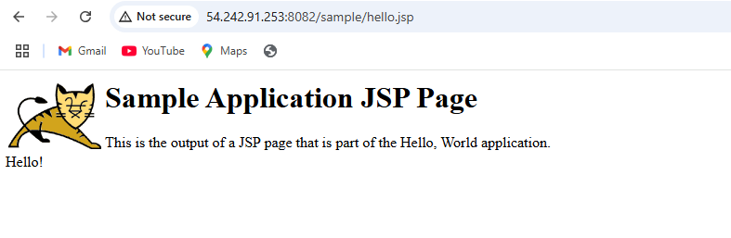

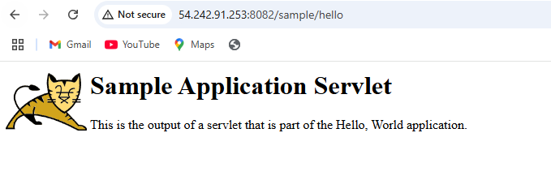

1. Create a tomcat.service file for tomcat.

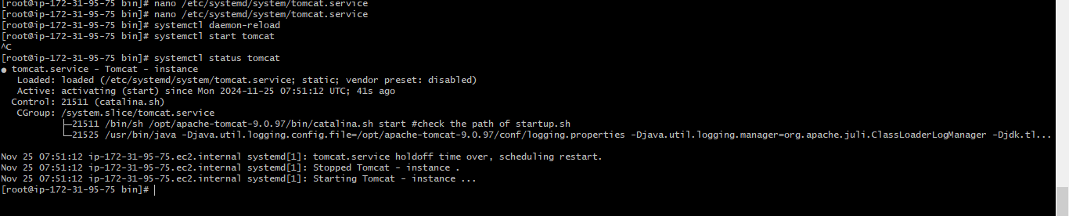

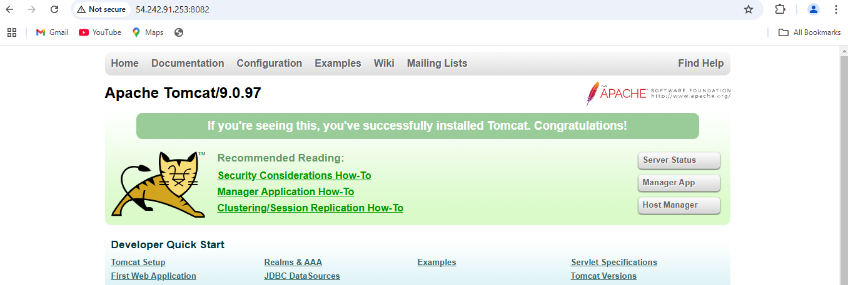

1. Configure HA Proxy server.